Soft Shadow

📘 Definition
# Source: AI Source: Provided by: [Data Path: Persons Table -> ID Column: 1, Name_En Column: Motasem Essam] -> From: [ChatGPT] on [5/2/2026]
A Soft Shadow is a type of shadow that has blurred or smooth edges. It forms when light comes from a large or diffused light source, so the shadow gradually fades instead of having a sharp outline.

🌫️ How soft shadows form
# Source: AI Source: Provided by: [Data Path: Persons Table -> ID Column: 1, Name_En Column: Motasem Essam] -> From: [ChatGPT] on [5/2/2026]
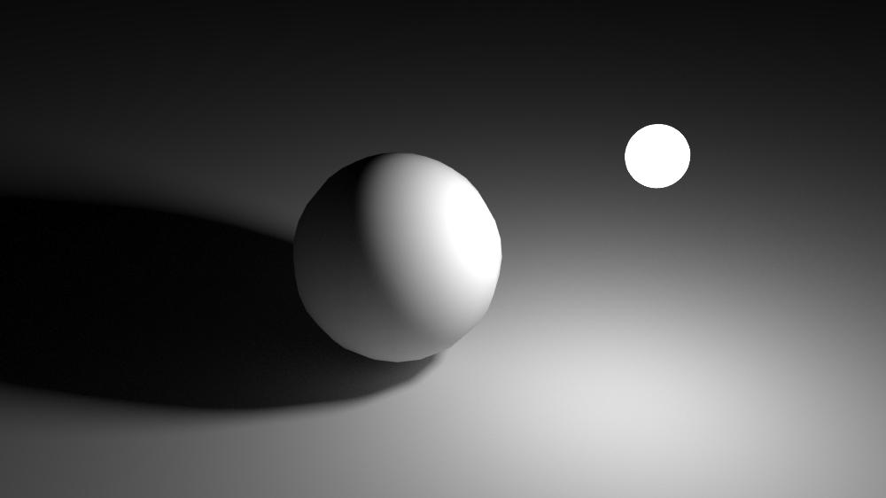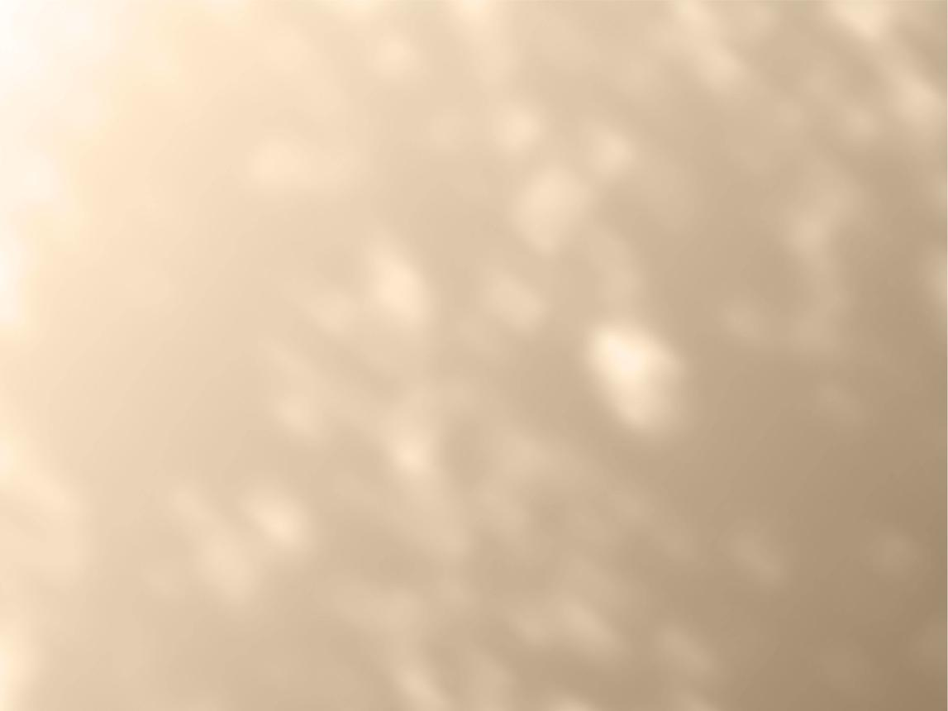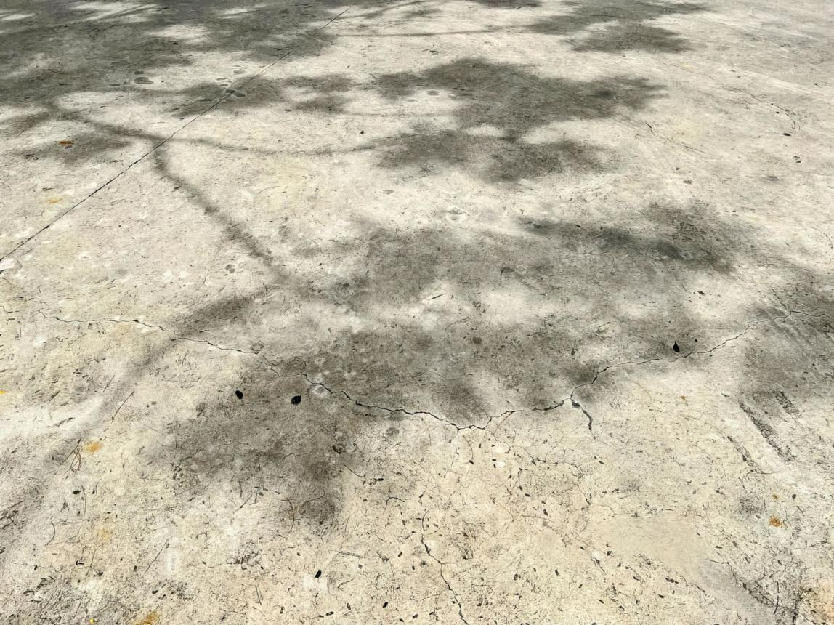
- Light comes from a large or spread-out source (like the sun through clouds)
- Light scatters in different directions
- Shadow edges become faded and smooth

🧠 Simple example
# Source: AI Source: Provided by: [Data Path: Persons Table -> ID Column: 1, Name_En Column: Motasem Essam] -> From: [ChatGPT] on [5/2/2026]
Think of:
- ☁️ Cloudy day sunlight → shadows look light and blurry
- 💡 Softbox light in photography → smooth, gentle shadows

🎮 Where soft shadows are used
# Source: AI Source: Provided by: [Data Path: Persons Table -> ID Column: 1, Name_En Column: Motasem Essam] -> From: [ChatGPT] on [5/2/2026]
- 🎮 Video games (for realism and depth)
- 🎬 Movies and CGI animation
- 📸 Photography and studio lighting
- 🧑‍🎨 3D rendering and digital art

⚙️ Key features
# Source: AI Source: Provided by: [Data Path: Persons Table -> ID Column: 1, Name_En Column: Motasem Essam] -> From: [ChatGPT] on [5/2/2026]
- 🌫️ Blurry, smooth edges
- 💡 Created by large or diffused light sources
- 🌑 Less harsh than hard shadows
- 🎯 More realistic and natural-looking

🚀 In short:
# Source: AI Source: Provided by: [Data Path: Persons Table -> ID Column: 1, Name_En Column: Motasem Essam] -> From: [ChatGPT] on [5/2/2026]
Soft Shadow = a smooth-edged shadow formed when light is spread out or diffused.

